milestone report

internal project report

Project code: RnD4Profit-15-02-016 Phosphorus efficient pastures
Prepared by: Doug Alcock
Graz Prophet Consulting
Date published: 1 Aug 2018

PUBLISHED BY
Meat and Livestock Australia Limited
Locked Bag 1961
NORTH SYDNEY NSW 2059
Phosphorus Efficient Pastures:
delivering high nitrogen and water use efficiency, and reducing cost of production across southern Australia
Activity B5. Extending the adaptation range of serradella systems
Milestone 6. 1 Feb 2019
Meat & Livestock Australia acknowledges the matching funds provided by the Australian Government to support the research and development detailed in this publication.
This publication is published by Meat & Livestock Australia Limited ABN 39 081 678 364 (MLA). Care is taken to ensure the accuracy of the information contained in this publication. However MLA cannot accept responsibility for the accuracy or completeness of the information or opinions contained in the publication. You should make your own enquiries before making decisions concerning your interests. Reproduction in whole or in part of this publication is prohibited without prior written consent of MLA.
Abstract

Very poor seasonal conditions prevailed across the Monaro from Autumn right through to the end of Spring 2018. The ploits sown in April were very slow to germinate and germinated in a staggered fashion making seedling counts problematic and delaying the other measurement activities right throughout the year.

Despite very low seedling counts at the time of sampling at Glen Finnan clearly some germination did occur once temperatures began to rise in Spring which mean’t that there were assessable amounts of the target legumes present at the time of Biomass sampling. It will remain to be seen whether these late established plants were able to set significant seed.

Even though the Avila Serradella was able to regenerate at original Redcliff west sowing, poor seasonal conditions and competition from weeds mean’t that very little biomass was produced and it was decided that biomass sampling would not yield any meaningful results and efforts were focussed on the 2018 sowing which had much better biomass and legume production.

Despite the poor conditions and staggered germination the 2018 sowing at Redcliff performed well during the spring with biomass reaching over 4000kgDM/ha on the Easterly aspect, much better that might have been expected given the season.

Both sites will need to be opened to grazing in February to reduce biomass for the best opportunity to regenerate.

Table of Contents

1 Milestone description 4
1.1 Key Performance Indicator(s) 4
2 Materials and Methods 4
2.1 Participatory Research Location 1 4
2.1.1 Location and Soil Type 4
2.1.2 Trial Design 4
2.2 Participatory Research Location 2 5
2.2.1 Location and soil type 5
2.2.2 Trials Design 5
2.3 Site Fertiliser use. 6
2.4 Trial Design 2018 sowing 7
3 Success in meeting the milestone 7
3.1 Results 7
3.1.1 Seedling Counts (Glen Finnan 2018 sowing) 7
3.1.2 Frequency Counts Redcliff 9
3.1.3 Biomass Composition Assessment 10
3.1.4 Spring Peak Yield Assessment 12
3.1.5 Soil Sampling 13
3.2 Discussion 13
4 Conclusions/recommendations 13
4.1 Site re-sowing 13
5 Communications 14
6 Appendix (optional) 15

Milestone description

Key Performance Indicator(s)
Peak spring yield & botanical composition assessments and soil testing completed, with data submitted to Graminus Consulting (within 4 weeks of collection) via the data management system. Briefly assess progress in the experiments; make recommendations on actions required to ensure research objectives can be met. Provide update on communication and extension activities...

Materials and Methods

Participatory Research Location 1

Location and Soil Type
Two participatory research sites have been established on the property Glen Finnan. The soil at this location is derived predominantly from the typical slate/shale association that crosses the Monaro and is a soil type that represents around a third of the arable area in the region.
Detailed soil testing for each trial site at this location was completed by replicate and the results shown in the table below.
 |  | Colwell P | Olsen P | PBI | PBI | KCl40 | Colwell K
 |  | mg/kg | mg/kg | colwell | unadjusted | mg/kg | mg/kg
Glen Finnan South | Rep 1 | 37.4 | 12 | 76.1 | 69.3 | 10.6 | 51.2
 | Rep 2 | 41.2 | 14 | 71.6 | 64.1 | 8.79 | 57.7
 | Rep 3 | 32.6 | 11.7 | 48.1 | 42.6 | 7.27 | 46.8
Glen Finnan East | Rep 1 | 18.4 | 6.2 | 44.2 | 41 | 6.5 | 81
 | Rep2 | 20.5 | 6.25 | 45.3 | 41.8 | 6.6 | 82.2
 | Rep 3 | 19.3 | 5.71 | 43.2 | 46.5 | 6.4 | 69.5
Soil P levels are significantly higher than indicated by the initial testing. This is most likely due to a mineralisation of P occurring after the paddock was browned out in spring. At the time of the first sample the conditions had been wett and pasture growth very good which may have resulted in the two tests being at the opposite ends of the seasonal range.
The Glen Finnan East site is still within the range of soil P desired for the experiment.

Trial Design
All trials were randomised using the spreadsheet tool provided by Graminus Consulting. Trial designs as they were applied in the paddock are shown below.

Participatory Research Location 2

Location and soil type
Two sites have been established on the property Redcliff. The soil at this site is also derived predominantly from the typical slate/shale association that crosses the Monaro.
Detailed soil testing for each trial site at this location was completed by replicate and is shown in the table below.
 |  | Colwell P | Olsen P | PBI | PBI | KCl40 | Colwell K
 |  | mg/kg | mg/kg | colwell | unadjusted | mg/kg | mg/kg
Redcliff East | Rep 1 | 16.1 | 4.74 | 56 | 53.2 | 5.5 | 279
 | Rep 2 | 15.3 | 5.7 | 55.5 | 52.8 | 7.7 | 291
 | Rep 3 | 13.5 | 5.81 | 56.8 | 54.4 | 7.5 | 284
Redcliff West | Rep 1 | 23.3 | 6.13 | 109 | 104.3 | 8.8 | 296
 | Rep2 | 25.3 | 5.42 | 107.1 | 102 | 8.7 | 353
 | Rep 3 | 21.4 | 5.54 | 94.3 | 90.2 | 7.2 | 288

Again the Colwell P levels were significantly higher than the original testing and is presumed to be the result of the mineralisation of P subsequent to the initial spray treatment of the sites. In the case of these sites at Redcliff the west site is around the dersired level on the basis of this second test but the Redcliff East site will require some additional P to bring it up to the target leve of around 20 mg/kg.

Trials Design
The Graminus spreadsheet was again used to randomise the plots and the layout of the Redcliff trials is shown below.

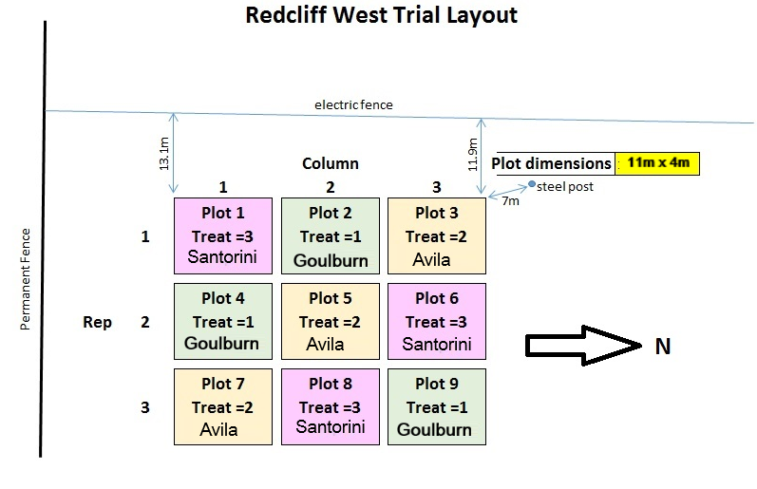

Site Fertiliser use.
Soil test information from samples collected in Spring 2017 was used to calculate appropriate levels of Phosphorous to be applied to achieve target P levels. In consultation with Richard Simpson it was decided to apply P differentially on each plot according to soil test and target P level. At Redcliff no soil tests were collected for the area to be sown in 2018 so no braod cast application of fertiliser was able to be calculated however 100kg/ha of Mo Superphosphate was applied through the drill at the time of sowing in April 2018
The original 2017 sown plots at redclif had the following application of Triple Superphosphate on the 25th of May 2018 in an attempt to lift the soil test to the target level for each plot.
Application of Triple Superphosphate to the 2017 sown plots at Redcliff
Triple Super Analysis |  |  | 21% | P
East | kg P/ha | kg TS/ha | g TS/plot |  |  | West | kg P/ha | kg TS/ha | g TS/plot
E1 | 12.4 | 60.19417 | 265 | g |  | W1 | 8.2 | 39.80583 | 175 | g
E2 | 5.7 | 27.6699 | 122 | g |  | W2 | 0 | 0 | 0 | g
E3 | 22.8 | 110.6796 | 487 | g |  | W3 | 10.2 | 49.51456 | 218 | g
E4 | 6.7 | 32.52427 | 143 | g |  | W4 | 11.6 | 56.31068 | 248 | g
E5 | 11.9 | 57.76699 | 254 | g |  | W5 | 3.7 | 17.96117 | 79 | g
E6 | 22.4 | 108.7379 | 478 | g |  | W6 | 7.1 | 34.46602 | 152 | g
E7 | 10.7 | 51.94175 | 229 | g |  | W7 | 0 | 0 | 0 | g
E8 | 9.7 | 47.08738 | 207 | g |  | W8 | 7.3 | 35.43689 | 156 | g
E9 | 18.7 | 90.7767 | 399 | g |  | W9 | 0 | 0 | 0 | g

At Glen Finnan where a resowing of the correct seed was attempted in 2017 soil tests were taking in late spring of 2017 so it was possible to determine whether the trial plots which were resown in 2018 needed any additional fertiliser. No fertiliser was used at sowing time through the seed drill.
Mostly the phosphorous levels exceeded the target levels desirable for the trial on all plots other than plots 1 and 5 of the Easterly Apsect and a small amount of triple superphosphate was applied to these plots on the 30th of May 2018 as shown in the table below.
Application of Triple Superphosphate to the 2018 sown plots at Glen Finnan
Triple Super Analysis |  |  | 21%
 | kg P/ha | kg TS/ha | g TS/plot |  |  | kg P/ha | kg TS/ha | g TS/plot
GSB1 | 0 | 0 | 0 |  | GEB1 | 3.7 | 17.96117 | 90.52427
GSB2 | 0 | 0 | 0 |  | GEB2 | 0 | 0 | 0
GSB3 | 0 | 0 | 0 |  | GEB3 | 0 | 0 | 0
GSB4 | 0 | 0 | 0 |  | GEB4 | 0 | 0 | 0
GSB5 | 0 | 0 | 0 |  | GEB5 | 11.2 | 54.36893 | 274.0194
GSB6 | 0 | 0 | 0 |  | GEB6 | 0 | 0 | 0
GSB7 | 0 | 0 | 0 |  | GEB7 | 0 | 0 | 0
GSB8 | 0 | 0 | 0 |  | GEB8 | 0 | 0 | 0
GSB9 | 0 | 0 | 0 |  | GEB9 | 0 | 0 | 0
 |  | Total | 0 |  |  |  | Total | 364.5

Trial Design 2018 sowing
Due to the sowing of an incorrect variety in 2017 the trial has ben resown at both sites. As reported the trial was resown in late Autumn of 2017 at Glen Finnan however this late sown trial failed to establish and was sprayed out in late spring of 2017 in preparation for resowing in 2018. At the Redcliff site initial preparation did not allow for the resowing of the trial in 2017 so an extended area was prepared for sowing in 2018 by spraying with Glyphosate in the spring and early summer of 2017-18. The two sites were resown on the 3rd and 4th of April 2017 using the original trial layouts shown above. Plots were also orientated the same way in relation to the slope but were sown using a different seed drill to 2017 so the plot dimensions have been altered to accommodate the machine used. Plot dimensions for the 2018 sowing are now 15m x 2.8m at the Redcliff site and 12m x 4.2m at the Glen Fnnan site.

Success in meeting the milestone

Results

Seedling Counts (Glen Finnan 2018 sowing)
The sites were revisited on the 18th of September for a general inspection. At this point there had been some germination occur and it was decided to do a germination count even though it was much later than planned. Due to cold and dry conditions only a few plants had begun to fully establish so a seedling count was more appropriate than a frequency count at this time.
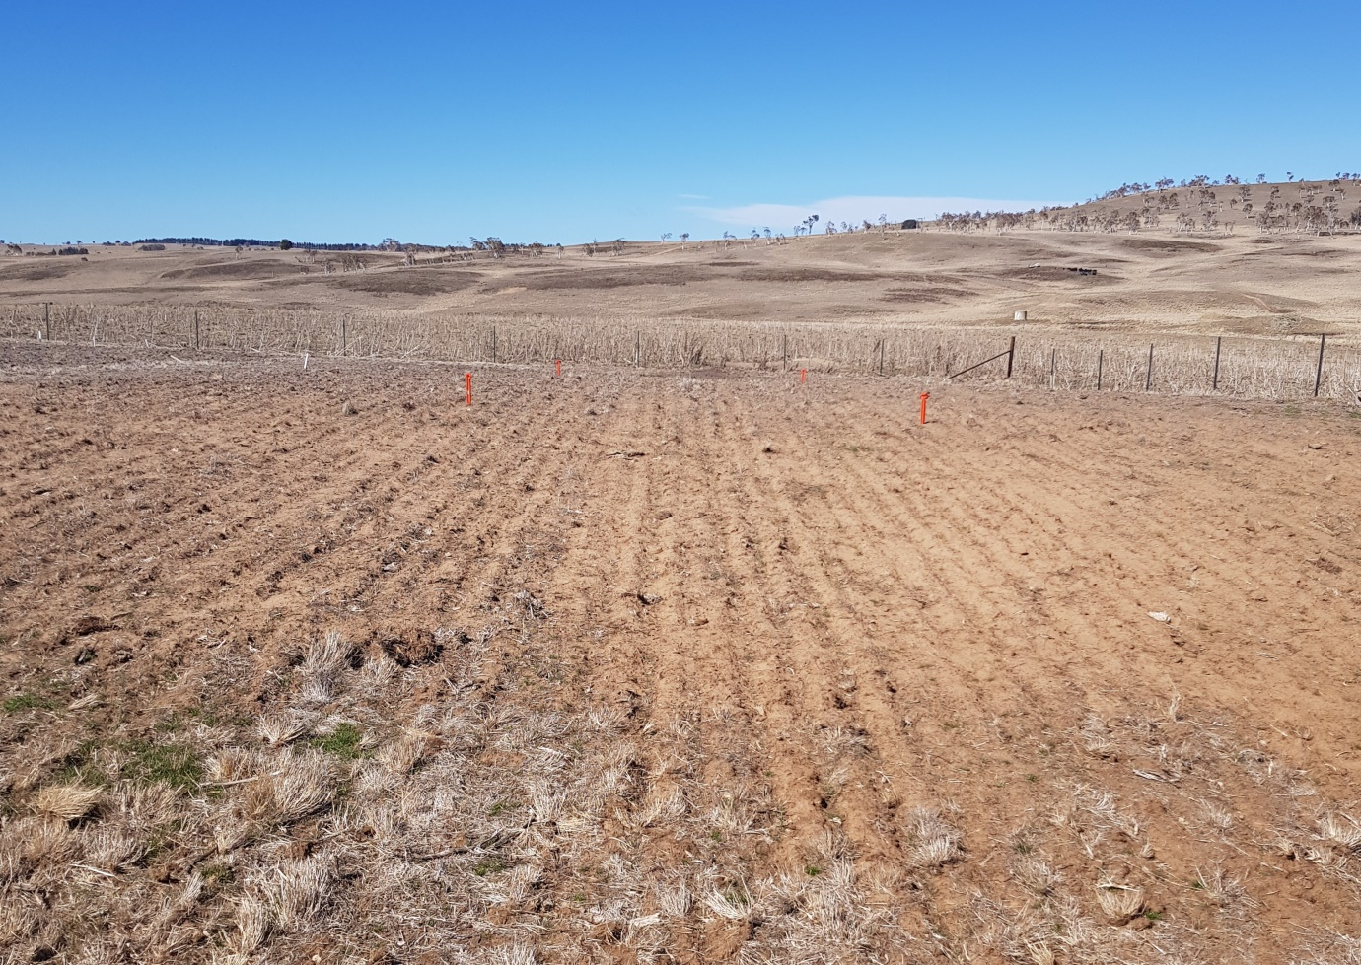
Overview of Glen Finnan South site on the 18^{h} of September 2018

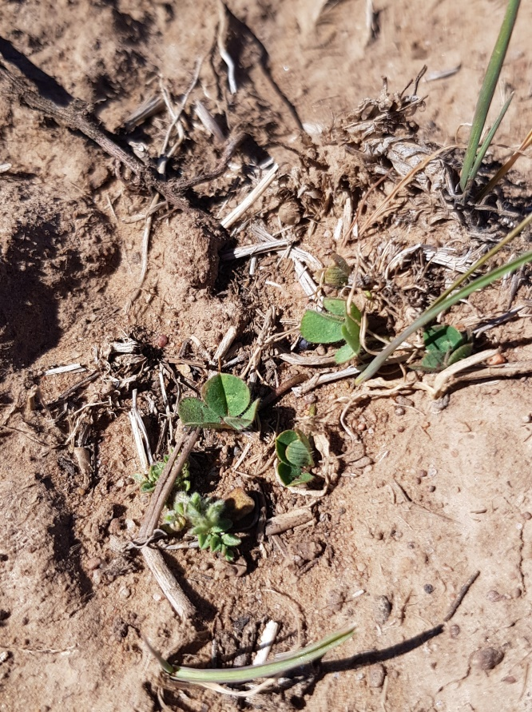 |  | 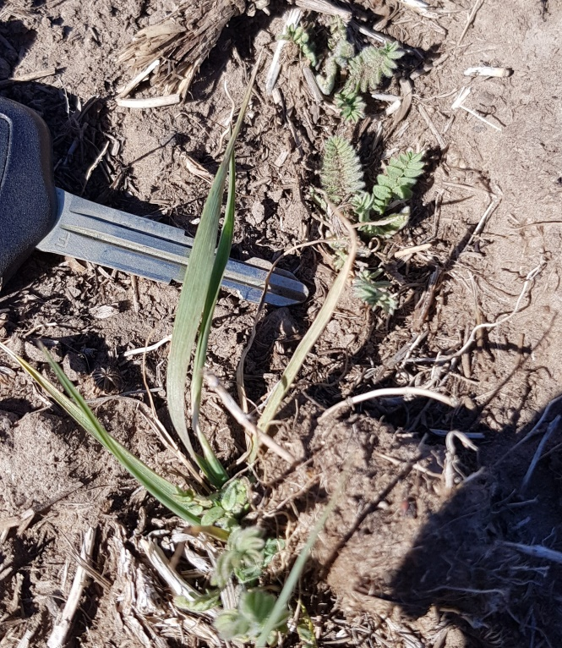
Typical Size of sub clover seedlings on the 18th of September 2018 |  | Typical size of Serradella and Phalaris seedlings on the 18th of September 2018

Overall the germination at Glen Finnan was poor even as late as mid September Seeling counts for each of the sown legumes was 12-14 plants/m² on the easterly aspect but were even lower on the southerly aspect with averaging less than 4 plants/m². 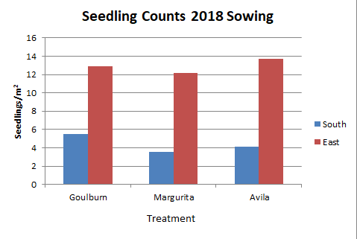

Frequency Counts Redcliff
Due to the late and staggered germination in 2018 the frequency counts were also delayed compared to planned dates. Frequency counts were taken on the 31st of October 2018 not long after warmer weather and some rainfall however growth response was very rapid and this measurement would have been better taken earlier on the 2018 sown plots.
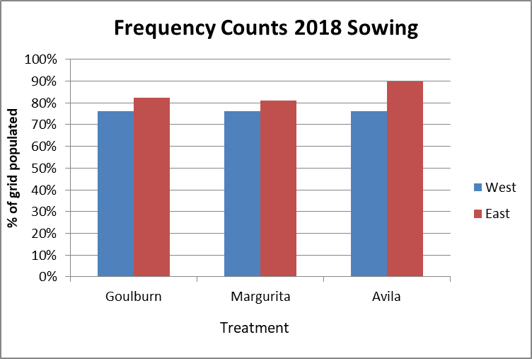 |  | 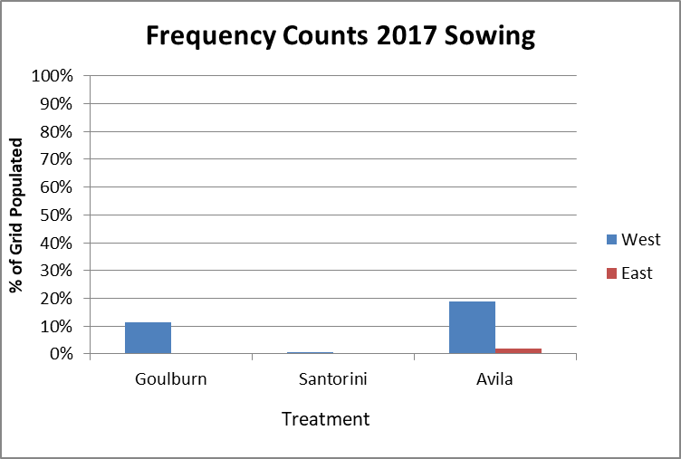
Redcliff Frequency counts taken 31 October 2018

It can be seen that the frequency counts were all high for the 2018 sown plots but the regeneration on the 2017 plots was poor and in line with the seedling counts taken earlier in 2018. Frequency was higher for the westerly aspect which is most likely due to the unplanned grazing of livestock which bared out these plots just prior to Autumn whereas the easterly aspect had not been as heavily grazed and retained a significantly higher overburden of residual herbage. Overall frequency for the 2018 sowing was highest on the easterly aspect but there was little difference between treatments.
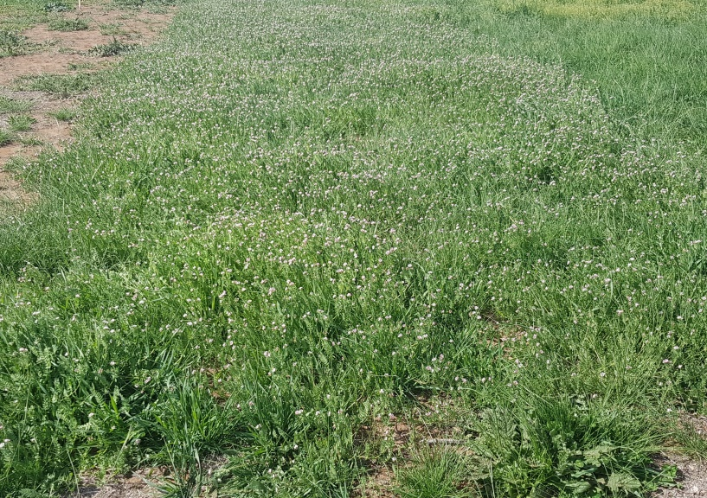 | 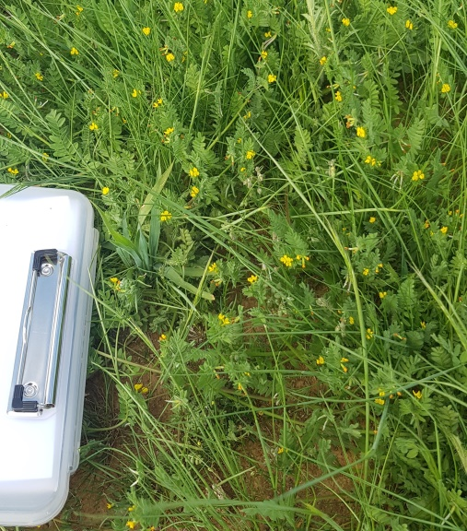
Magurita plot 2 Red East 2018 Sowing | Avila Serradella Red West 2018 sowing

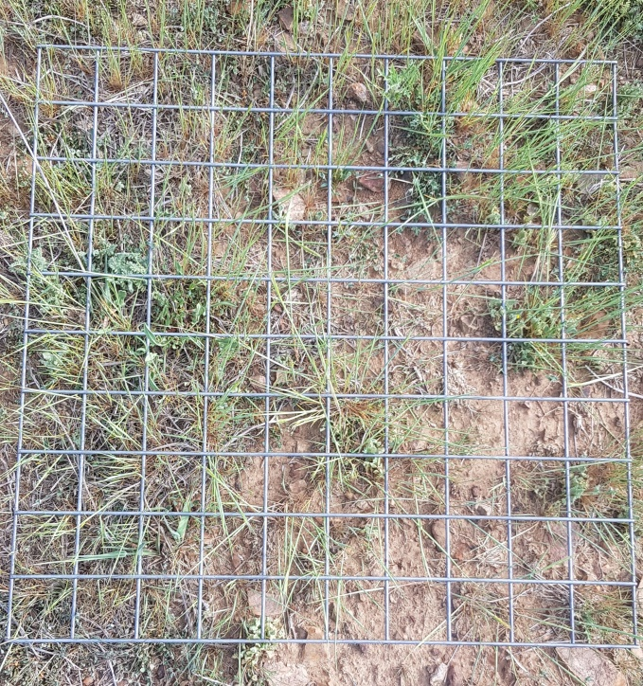 | 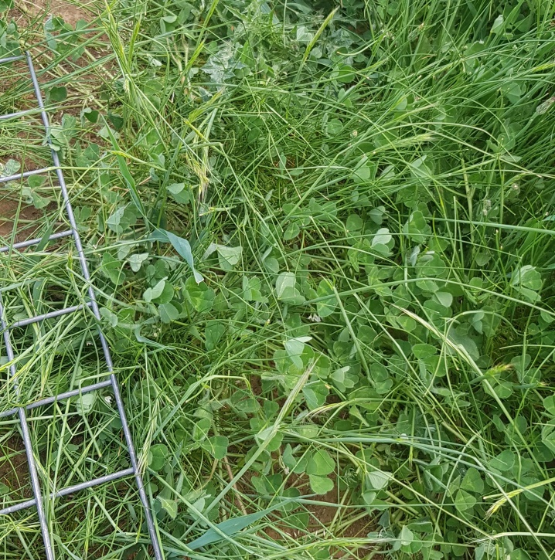
Typical cover Red West 2017 Sowing | Goulburn Sub Red West 2018 sowing

Biomass Composition Assessment
Composition assessments were done at the same time as biomass assessments and were completed on the 6th of November at Redcliff and the 6th of December at Glen Finnan.
Despite the poor seasonal conditions the weed control was much better for the 2018 sowing compared with the 2017 sowing and the composition was dominated by the target own species. For the Red East sowing both the Margurita and the Avila made the greatest contribution to the biomass with phalaris ranking second. Together the legume and perennial grass made up around 70-75% of the biomass.Annual grass made up 15-20% of the biomass and there was only a small contribution from broadleaf weeds at the time of sampling.
At the Red West site the legumes contributed a similar proportion of the biomass but on the dryer and warmer aspect annual grasses especially Vulpia spp contributed more to biomass than the sown Phalaris.
Figure 3.1.3.1 Composition as a percentage of Biomass at Redcliff 6th Nov 2018.
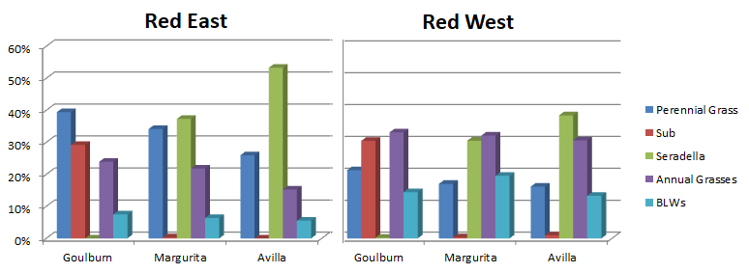
At Glen Finnan the composition sampling was delayed until the 6th of December to allow more biomass to accumulate. Despite the very poor germination and frequency data it appears that once this high altitude site had warmed up in Sept/Oct there was significant further germination of the serradellas although the performance of Goulburn Sub Clover was poor. On the Southerly aspect the sown perennial grass Phalaris, contributed the greatest proportion of the biomass at around 40% while annual grasses and broadleaf weeds together contributed a further 40-50%. There was negligible contribution from Sub Clover but bothe Margurita and Avila Serradellas were around 10% of the biomass. On the easterly aspect the perennial grass component hovered around 30% with the difference being mad up equally of annual grasses and broadleaf weeds in the Goulburn treatment but with serradella making up the difference at the expense of broadleaf weeds in the Avila treatment. Given the poor showing in the very late seedling counts Avila did very well to reach 25% of the biomass and with ongoing rainfall in December is likely to have successfully set seed.
Figure 3.1.3.2 Composition as a percentage of Biomass at Glen Finnan 6th Dec 2018.
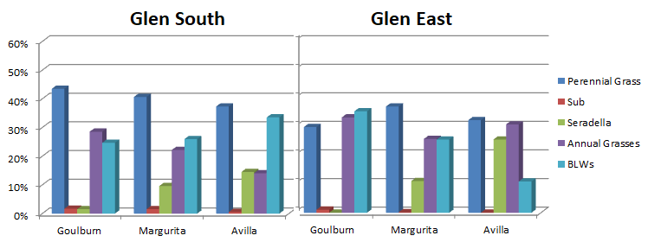

Spring Peak Yield Assessment
At Redcliff biomass cuts were taken and weighed on site, sub samples were then prepared and weighed wet on site before being taken to drying ovens at the UNSW Coolringdon site for the purpose of determining the dry matter percentage. At Glen Finnan the biomass was relatively small so the entire biomass cut was retained for drying.
At Redcliff total biomass was similar across treatments on each aspect but again the total biomass was higher on the Easterly aspect presumably due to the drying effect of the afternoon sun and the shallower depth of soil. Of the sown legumes Avila again produced the highest biomass which on the Easterly aspect was almost double that of the Goulburn Sub Clover. Given the poor season the total biomass produced was remarkably good.
Figure 3.1.4.2 Biomass at Redcliff 6th Nov 2018.
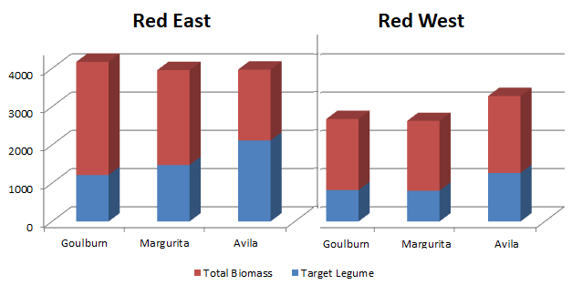
Figure 3.1.4.2 Biomass at Glen Finnan 6th Dec 2018.
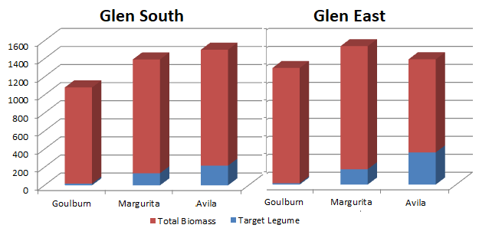 At Glen Finnan total biomass produced was very poor but given the expremely late germination of both sown species and weeds this should be no surprise.Both aspects produced similar biomass which was also similar across treatments averaging around 1300 kgDM/ha. Although the Goulburn Sub Clover treatment on the Southerly aspect had the lowest biomass. At around 1000kgDM/ha. Avila remained the best performing of the sown legumes but its total biomass was still very low ranging from 180 – 300kgDM/ha depending on the aspect.

Soil Sampling
As per the sampling schedule each plot on the 2018 sown sites at both Glen Finnan and Redcliff were sampled and the soil samples delivered diretly to CSIRO in Canberra. Soils were sampled on the 29th of November at Redcliff and the 6th of December at Glen Finnan after rainfall events to assist with sampling.

Discussion
Growing conditions on the Monaro over the Autumn- Spring period on the Monaro were on a par with other severe drought years such as 1980, 1986 and 2008. Given the conditions the weed control was better on the 2018 sown plots and despite the battle to establish the target legumes performed well and should have set considerable seed on the Redcliff sites. Unfortunately cattle broke into the Red East plots before flowering was completed and it is likely that some unripe pods will have been consumed which may compromise the amount of seed which reach the soil seed bank.The Red West trial had no such challenge and should have set good amounts of seed. Saffron Thistles did again become an issue in December and some hand application of Glyphosate was done to try and arrest there development and kill them before they could set seed.
At Glen Finnan the germination was extremely late and the perfoamnce of the sown pasture suffered accordingly. The elevation at this site means that sowing time is critical and the April sowing in 2018 was again too late for ideal performance. A late February to March sowing would be a better proposition but unfortunately sowing equipment was not available until ealy April. Given the Serradella species sown are non determinant it is liklely that with December rain they would have continued to flower and set seed so regeneration next year is a possibility. Unfortunately the Goulburn sub clover was a failure and will not have set any significant amount of seed which will compromise any comparisons between sub clover and serradella at this site next year.

Conclusions/recommendations

Site re-sowing
The 2018 sowing at both sites should have set sufficient seed to give an opportunity for some regeneration in 2019 alleviating any need for urther sowing. We know from the 2017 sowing that Avila shows some ability to regenerate in out environment so we must hope for better seasonal conditions than 2018 to give these legumes a chance to show what they can do in a better season.

Communications
Preliminary results were presented to the MFS meeting in December (Approximately 50 producers were present ).

Appendix (optional)

